Quantifying the Damage: A Data-Driven Evaluation of COVID-19 Mortality and Healthcare Strain

Mortality Metrics
This section analyzes COVID-19 mortality trends in the United States from mid-2020 through mid-2023. Using both raw mortality indicators (new deaths, total deaths) and derived severity metrics (case fatality rate, ICU rate, hospitalization rate), we examine how mortality evolved and how different phases of the pandemic can be distinguished.

Time-Series Analysis of Mortality Trends
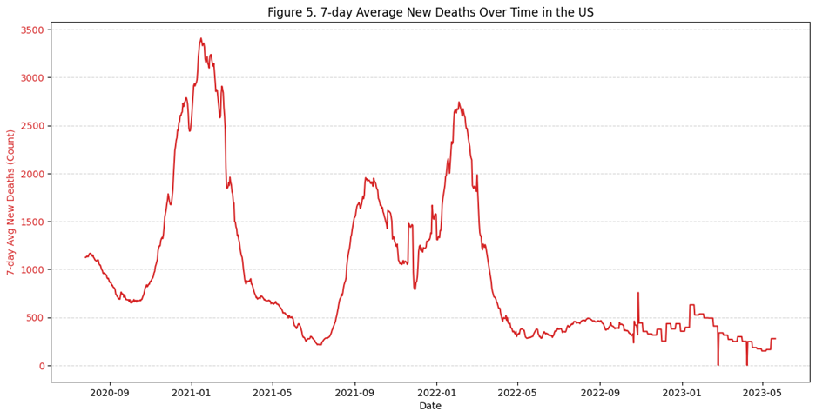
The plot of the 7-day average of new deaths reveals clear, distinct mortality waves throughout the pandemic:
- Wave 1 (Winter 2020 - 2021): The deadliest and most prolonged mortality spike occurred between December 2020 and January 2021, peaking above 3,000 deaths per day. This aligns with the pre-vaccination environment.
- Wave 2 (Late 2021 - Early 2022): A second major spike appears during the Delta variant (Sept - 2021) and Omicron variant (late 2021 - early 2022) waves. Although Omicron was less severe, its sheer transmissibility produced a significant mortality rise.
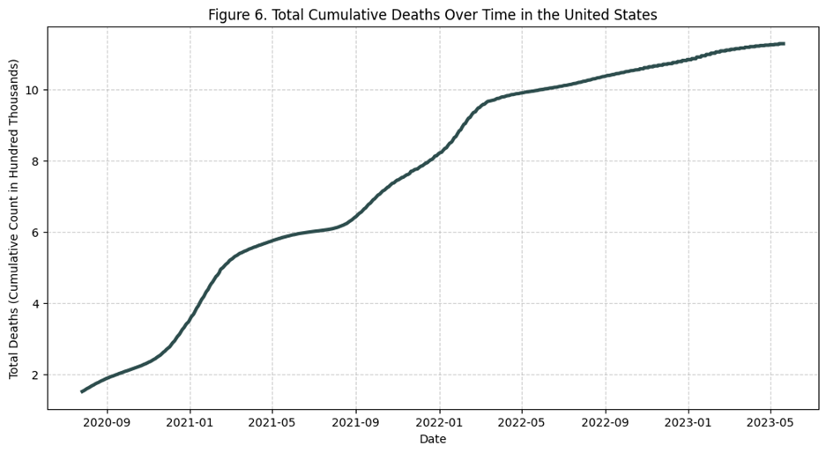
- Declining Trend in 2022–2023: After early 2022, the mortality curve steadily declines. Sporadic, smaller bumps persist, but deaths remain far below earlier numbers.
This plot shows how the total number of COVID-19 deaths in the United States increased over time, from mid-2020 to mid-2023. During early 2021, the total deaths rapidly rose from approx 200k to approx 500k cases, marking the deadliest period of the U.S. pandemic. Around mid-2021, the curve starts to flatten, indicating fewer deaths per day. This aligns with the mass vaccination campaign, which began in early 2021. A second sharp incline appears in late 2021 to early 2022, corresponding to the Delta and Omicron variant waves. After early 2022, the rate of increase becomes much slower. By 2023, daily death counts had significantly decreased and stabilized.

Pandemic Phase Classification Using Clustering
To better understand different mortality levels, we used K-Means clustering on four key severity and mortality indicators, which are 7-day average new deaths, case fatality rate (CFR), ICU rate and hospitalization rate. This unsupervised clustering uncovers natural groupings of pandemic days based on severity patterns rather than arbitrary calendar boundaries.
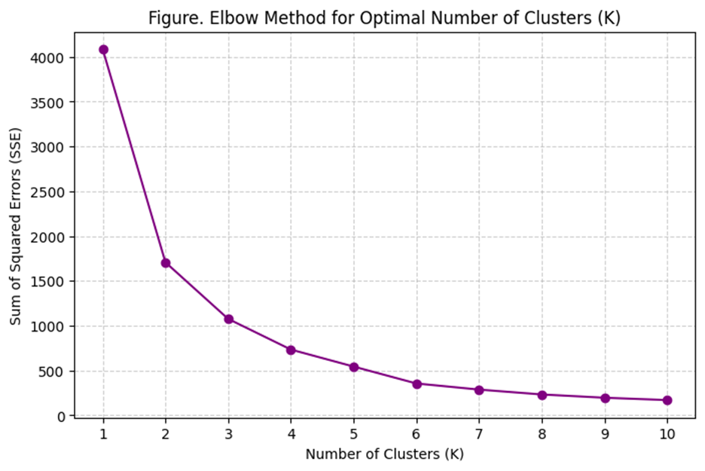
Elbow Method to Determine Optimal k
Determining the Number of Phases (k), the elbow method is used to find the optimal number of clusters (k). The plot of the Sum of Squared Errors (SSE) often shows a sharp "elbow" where adding more clusters yields diminishing returns. For this dataset, a clear elbow often appears at k=3, so I chose k=3 to define three highly interpretable phases of the pandemic.
Cluster Characteristics
After training, the model identified three distinct mortality phases, the highest, mid-level, and lowest mortality rates, each representing a unique pandemic condition:
Cluster 1 (High deaths, moderate severity): Characterized by the highest death counts but only moderate severity rates (CFR, ICU). This cluster represents the massive volume surges where the sheer number of cases drove up the deaths.
Cluster 2 (High severity rates, early pandemic): Characterized by having the highest mortality and severity rates (CFR approx 2.64%, ICU Rate approx 0.16%).
Cluster 3 (Endemic Stability State): Characterized by the lowest values across all metrics, representing the post-vaccine endemic periods.
Phase Distribution Over Time
By visualizing the clusters along the timeline (Figure 7), it shows a clear chronological segmentation: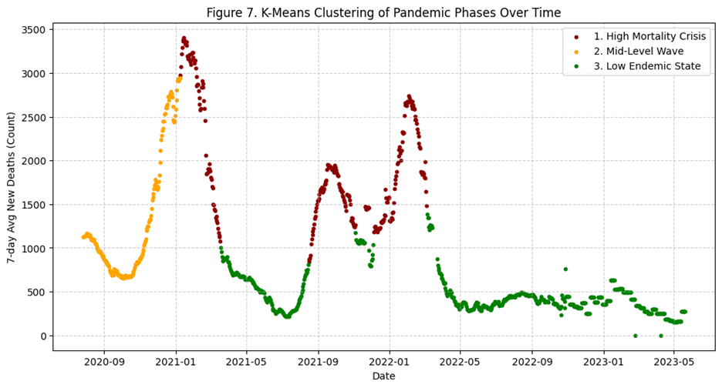
This figure shows how the three mortality phases map onto the pandemic timeline. High-severity and high-mortality conditions are clustered early on, while milder endemic conditions dominate the later period. The segmentation reflects the COVID-19 real-world epidemiological transitions driven by vaccination, immunity, and changing variants.

